PROJECT REPORT
on
PASSWORD POLICY TESTING & CREDENTIAL SECURITY ASSESSMENT SUITE

Submitted By
Mr. Mayank Ninama

Course: Cybersecurity

1. Abstract
Passwords continue to be one of the most targeted components of modern authentication systems. Weak, reused, predictable, or commonly used passwords can expose organizations and individuals to account takeover, credential stuffing, unauthorized access, and data breaches. Attackers commonly use dictionary-based attacks, password mutation rules, leaked-password lists, and high-speed offline guessing techniques to identify vulnerable credentials.
CIPHERGUARD – Password Policy Testing & Credential Security Assessment Suite is a full-stack cybersecurity web application developed using Python, Flask, HTML, CSS, and JavaScript. The system provides an integrated environment for evaluating password strength, estimating theoretical password-cracking resistance, checking password-policy requirements, performing controlled Red Team-style password mutation analysis, inspecting password-hash formats, and conducting bulk organizational password-security audits.
The project follows a Dual-Team Cyber Assessment Model, combining Red Team offensive risk assessment with Blue Team defensive security analysis. The application also provides visual security metrics and generates executive-ready security reports.
The primary goal of CIPHERGUARD is to help users understand password-related security risks while demonstrating practical cybersecurity concepts in a controlled and defensive environment.

2. Introduction
Authentication is a fundamental security mechanism used to protect applications, databases, networks, cloud services, and digital identities. Although modern systems increasingly support multi-factor authentication and passwordless technologies, passwords remain widely used.
A password that appears complex to a human user may still be predictable to an automated attack system. Examples include passwords containing common words followed by years, predictable substitutions such as @ for a, or simple keyboard sequences.
Traditional password-strength meters often evaluate only basic properties such as length and character variety. CIPHERGUARD provides a broader assessment by combining:
- Password length and character-set analysis
- Mathematical search-space estimation
- Pattern and repetition analysis
- Dictionary and leet-speak normalization
- Password-policy evaluation
- Theoretical crack-time estimation
- Hash-format identification
- Bulk password-security auditing
- Security report generation
The system therefore provides a practical platform for understanding both password attack risks and defensive password-security practices.

3. Problem Statement
Many users and organizations continue to rely on weak or predictable passwords. Password policies may also be poorly designed, inconsistently enforced, or based on outdated assumptions about password security.
Common weaknesses include:
- Use of short passwords.
- Use of common dictionary words.
- Predictable substitutions such as P@ssw0rd.
- Reuse of passwords across multiple services.
- Passwords based on names, dates, or common patterns.
- Use of outdated password-hashing algorithms.
- Lack of centralized password-security auditing.
- Difficulty in communicating password risks to non-technical users.
Existing password-strength tools generally focus on individual passwords and may not provide an integrated Red Team and Blue Team assessment environment.
Therefore, there is a need for a controlled cybersecurity application that can evaluate password security from multiple perspectives and provide understandable security recommendations.

4. Motivation
The project is motivated by the increasing number of cybersecurity incidents involving compromised credentials.
Weak credentials can contribute to:
- Account Takeover
- Credential Stuffing
- Brute-Force Attacks
- Unauthorized System Access
- Privilege Abuse
- Identity Theft
- Data Breaches
- Financial Fraud
CIPHERGUARD attempts to address these risks by providing users with a practical environment to understand how password characteristics influence security.
The project also demonstrates how cybersecurity concepts can be integrated into a full-stack web application.

5. Objectives
5.1 Password Strength Analysis
Analyze a password based on length, character diversity, patterns, repetition, and estimated search space.
5.2 Entropy Estimation
Calculate theoretical entropy using:
[ H = L \times \log_2(N) ]
where:
- (H) = estimated entropy in bits
- (L) = password length
- (N) = estimated character-set size
5.3 Password Policy Assessment
Evaluate passwords against selected security-policy requirements and identify weak or commonly predictable credentials.
5.4 Controlled Red Team Simulation
Model password mutation techniques such as:
- Dictionary-word transformations
- Case changes
- Numeric suffixes
- Special-character additions
- Leet-speak substitutions
5.5 Hash Format Inspection
Identify common password-hash formats and provide defensive recommendations regarding legacy and modern password-storage approaches.
5.6 Enterprise Batch Auditing
Allow authorized security administrators to evaluate multiple password samples and calculate organizational security metrics.
5.7 Security Reporting
Generate a security report containing risk scores, findings, and recommended mitigation strategies.
6. Scope of the Project
CIPHERGUARD is designed as a defensive password-security assessment and educational tool.
Included in Scope
- Password-strength analysis
- Entropy estimation
- Pattern detection
- Leet-speak normalization
- Controlled mutation modeling
- Password-policy evaluation
- Hash-format identification
- Bulk security assessment
- Risk visualization
- Report generation
Outside the Scope
The system does not attempt to:
- Access real user accounts.
- Crack real-world credentials.
- Bypass authentication systems.
- Attack third-party websites.
- Recover passwords from unauthorized systems.
- Perform unauthorized penetration testing.
All offensive functionality is intended for controlled laboratory and defensive assessment purposes.

7. System Architecture
Flowchart
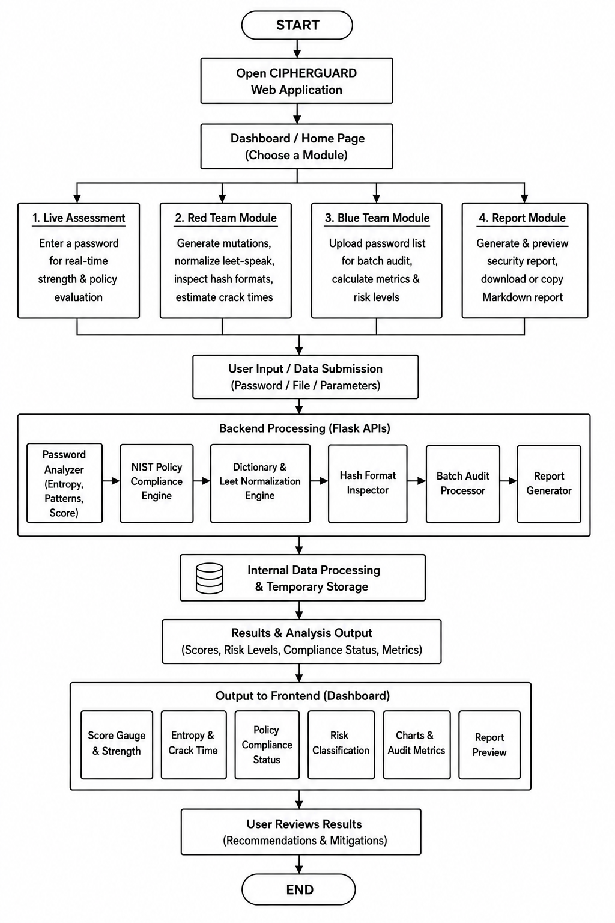

Architecture:
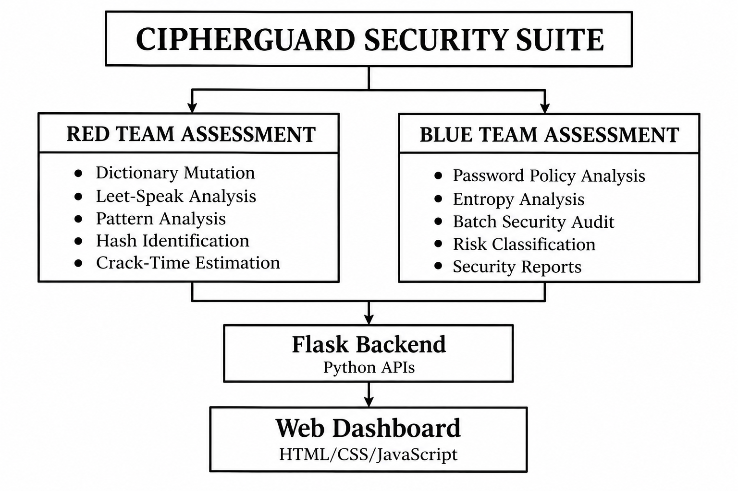

8. System Modules
8.1 Live Password Assessment Module
This module accepts a password for analysis and displays:
- Overall security score
- Password length
- Character categories
- Estimated entropy
- Detected patterns
- Risk classification
- Policy-compliance status
- Theoretical crack-time estimates
The results are presented through an interactive dashboard.
8.2 Mathematical Entropy Engine
The entropy engine estimates the theoretical size of the password search space.
The basic formula is:
[ H = L \log_2(N) ]
For example, if a password uses a character pool of 94 possible characters and has length (L), its theoretical maximum entropy can be estimated using:
[ H = L\log_2(94) ]
However, mathematical entropy should not be interpreted as a guarantee of real-world security. Predictable patterns, dictionary words, repeated characters, and known password structures can significantly reduce practical resistance to guessing.
Therefore, CIPHERGUARD supplements the theoretical calculation with pattern-based risk analysis.
8.3 Pattern Detection
The system identifies common password weaknesses such as:
- Repeated characters
- Sequential numbers
- Keyboard walks
- Common words
- Predictable suffixes
- Repeated structures
- Excessive character repetition
Examples include:
123456
qwerty
password123
admin2026
abcdef
These patterns can make passwords substantially easier for automated guessing systems to predict.

9. Red Team Assessment Module
The Red Team module models common password-guessing strategies in a controlled environment.
9.1 Dictionary Mutation
A base dictionary term can be transformed using predictable rules such as:
password
Password
PASSWORD
password1
password123
password2026
Password!
The purpose is not to attack real systems but to demonstrate why predictable password modifications should not be considered sufficient protection.
9.2 Leet-Speak Normalization
The system recognizes common substitutions, including:
Character | Normalized Character
@ | a
3 | e
1 / ! | i
0 | o
$ / 5 | s
For example:
P@ssw0rd
can be normalized approximately to:
password
This demonstrates that simply replacing letters with visually similar symbols does not necessarily make a dictionary password resistant to automated guessing.

10. Theoretical Crack-Time Estimation
CIPHERGUARD estimates theoretical guessing time under different attack scenarios.
The basic calculation is:
[ SearchSpace = 2^H ]
The approximate average number of attempts is:
[ AverageAttempts = \frac{2^H}{2} ]
The theoretical time can then be estimated as:
[ Time = \frac{AverageAttempts}{GuessRate} ]
The project models different environments, including:
- Rate-limited online authentication.
- High-speed API guessing.
- Fast offline password-hash guessing.
- Standard cryptographic hashing scenarios.
- Memory-hard password KDF scenarios.
These values are illustrative estimates, because actual attack performance depends on the password distribution, hash algorithm, hardware, implementation, configuration, and attack strategy.

11. Blue Team Defensive Module
The Blue Team module focuses on identifying password-security weaknesses and improving organizational security.
It provides:
- Password-policy evaluation
- Batch password analysis
- Security-score calculation
- Risk-level classification
- Weak-password identification
- Security recommendations
- Executive reporting
The module can be used by security administrators to identify general trends in password quality without attempting unauthorized account access.

12. Password Policy Compliance
CIPHERGUARD evaluates candidate passwords against selected password-security requirements.
The system can evaluate factors such as:
- Minimum password length
- Common-password detection
- Dictionary-word detection
- Repetition
- Predictable sequences
- Passphrase characteristics
Important Security Note
NIST's modern password guidance emphasizes longer passwords/passphrases and screening against commonly used or compromised passwords rather than relying heavily on traditional composition rules such as mandatory combinations of uppercase letters, numbers, and symbols.
Therefore, CIPHERGUARD treats policy evaluation as a configurable assessment layer rather than claiming that every traditional complexity rule is a direct NIST requirement.

13. Hash Format Inspector
Password hashes should be stored using appropriate password-hashing or password-based key-derivation mechanisms.
CIPHERGUARD identifies common formats for defensive assessment.
Examples include:
Format | Example Indicator | Security Context
SHA-512 crypt | $6$ | Legacy Unix password format
SHA-256 crypt | $5$ | Legacy Unix password format
MD5 crypt | $1$ | Legacy and weak
Yescrypt | $y$ | Modern password hashing
bcrypt | $2b$ | Adaptive password hashing
Argon2id | $argon2 | Modern memory-hard KDF
NTLM | 32 hexadecimal characters | Legacy Windows credential format
The module does not perform password recovery. It only identifies likely hash formats and provides defensive recommendations.

14. Enterprise Batch Audit
The Enterprise Audit module allows authorized administrators to submit a collection of password samples for security evaluation.
The system calculates metrics such as:
- Percentage of weak passwords
- Percentage of compliant passwords
- Average security score
- Risk-level distribution
- Common patterns
- Policy failures
Example output:
Total Passwords Analyzed: 100
Strong: 62%
Moderate: 23%
Weak: 15%
The information can be displayed using interactive charts for easier interpretation.

15. Web Interface
The CIPHERGUARD interface is designed as a cybersecurity dashboard.
Main Interface Components
Live Assessment
Displays:
- Password score
- Entropy
- Security level
- Detected weaknesses
- Crack-time estimates
- Policy status
Red Team Tab
Provides:
- Mutation analysis
- Leet normalization
- Hash-format inspection
- Controlled security-testing information
Blue Team Tab
Provides:
- Batch auditing
- Security metrics
- Risk distribution
- Compliance statistics

Report Tab
Provides:
- Report preview
- Security findings
- Recommendations
- Copy functionality
- Markdown report export

16. User Interface Design
The application supports both Dark Mode and Light Mode.
The selected theme is stored using browser localStorage, allowing the user's preference to remain available after refreshing the page.
The interface is designed to be:
- Responsive
- Easy to navigate
- Visually informative
- Suitable for security demonstrations
- Appropriate for academic presentations

User interface snapshots:
- DUAL assesment
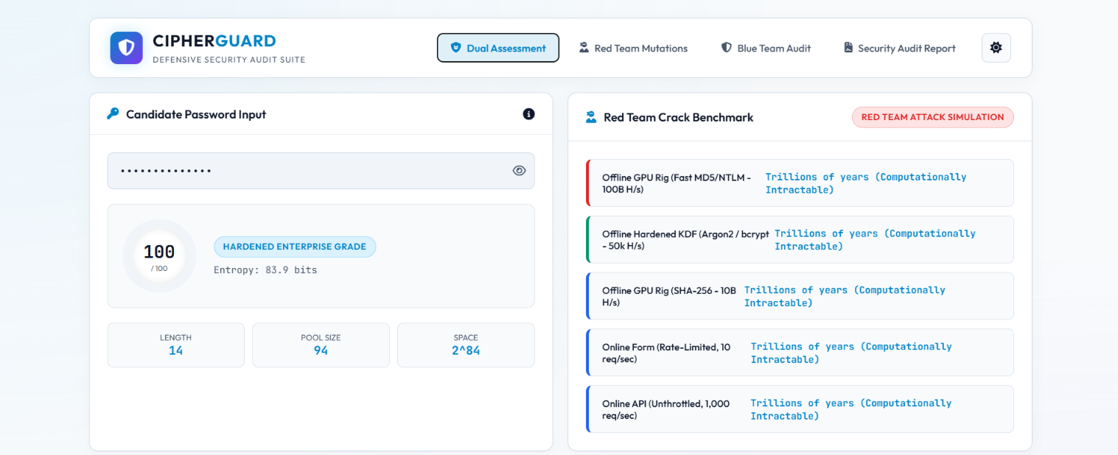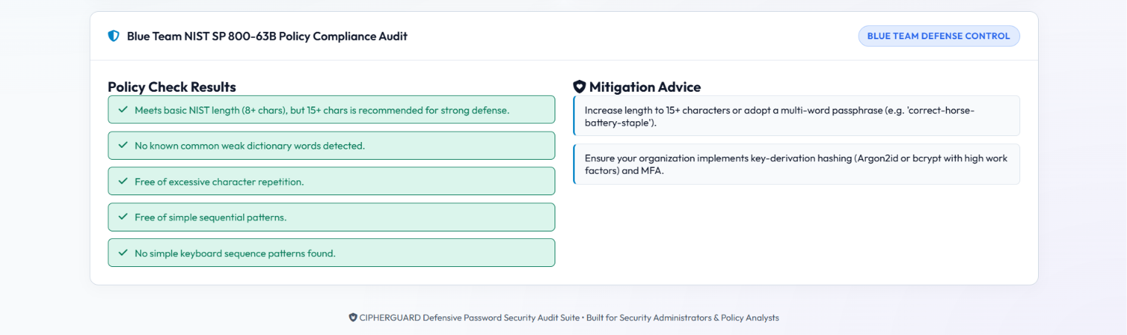

- Red Team Mutation
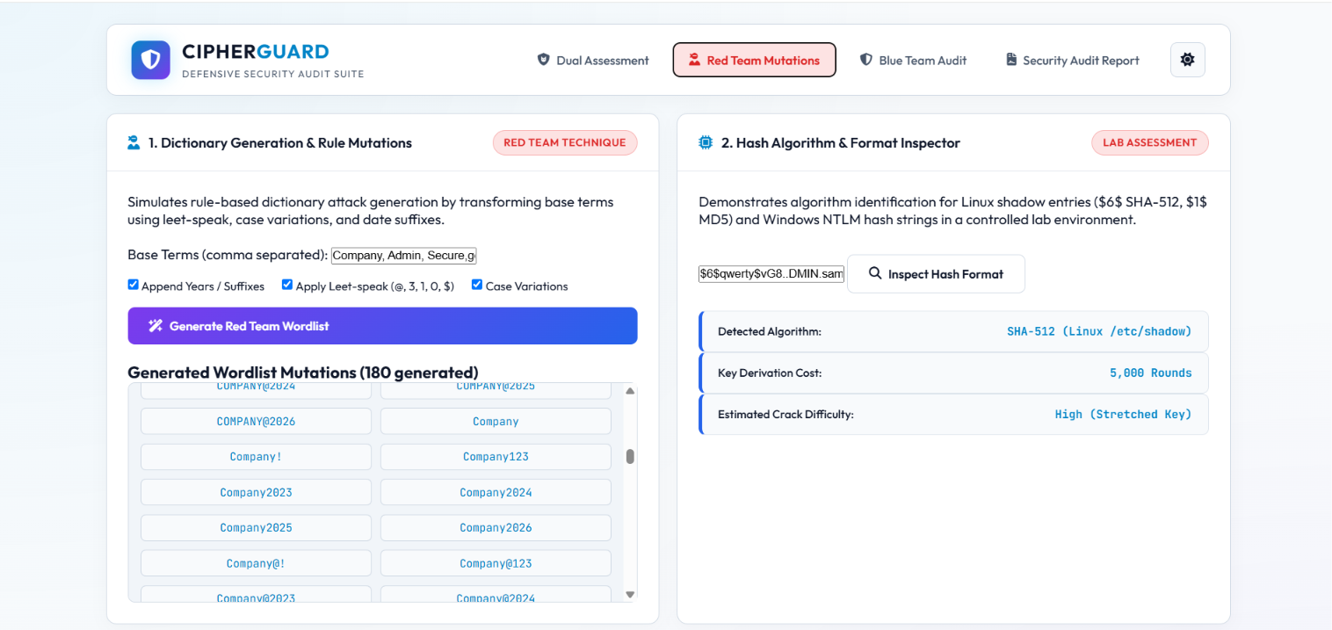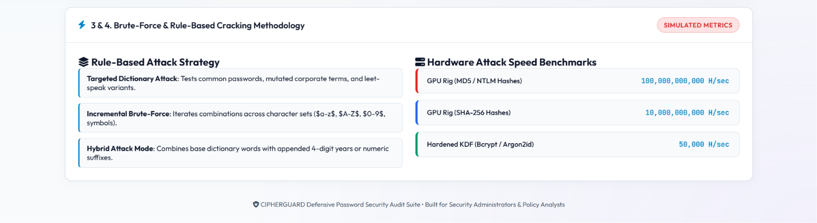
- Blue Team Audit
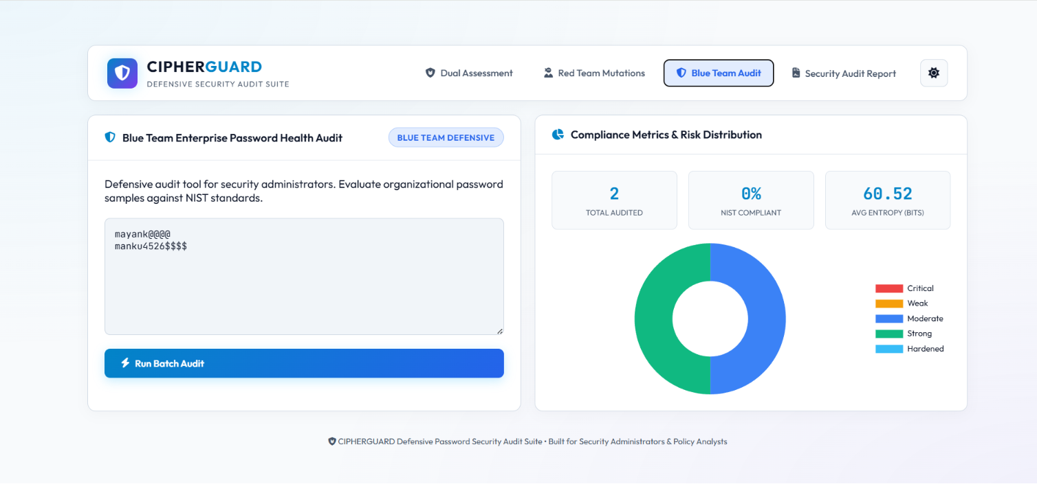

- Security Report Audit
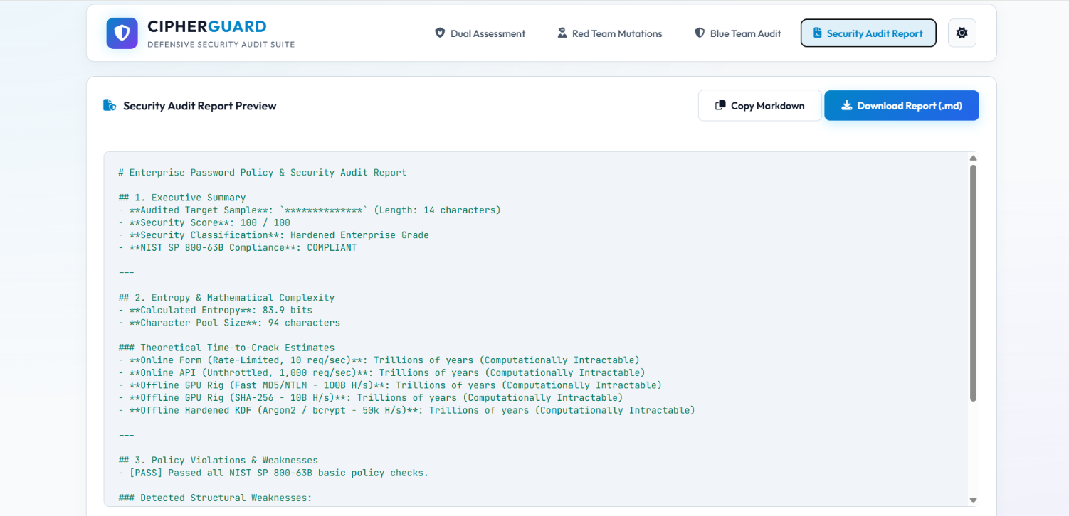

17. Technology Stack
Technology | Purpose
Python | Core application logic
Flask | Backend web framework
HTML5 | Webpage structure
CSS3 | User interface design
JavaScript | Frontend interaction
Chart.js | Data visualization
Jinja2 | Flask template rendering
Python Unit Testing | Automated testing
Markdown | Security-report generation

18. Sample Test Cases
Test Case 1 – Weak Password
Input:
123456
Expected Result:
- Very low security score
- Low entropy
- Sequential-pattern warning
- Policy failure
- High-risk classification
Test Case 2 – Predictable Password
Input:
P@ssw0rd123
Expected Result:
- Leet-speak normalization detected
- Dictionary-pattern warning
- Predictable numeric suffix detected
- Reduced practical security assessment
Test Case 3 – Strong Passphrase
Input:
correct-horse-battery-staple
Expected Result:
- Long password/passphrase
- Strong security characteristics
- Low predictability relative to short common passwords
- Policy assessment based on configured rules

19. Advantages
The major advantages of CIPHERGUARD are:
- Dual Red Team and Blue Team perspective
- Interactive password-security dashboard
- Mathematical entropy estimation
- Pattern and repetition detection
- Leet-speak normalization
- Controlled password mutation modeling
- Hash-format identification
- Bulk organizational auditing
- Automated testing
- Executive-ready security reports
- Dark and Light UI support
- Full-stack implementation using Python and Flask

20. Limitations
Although CIPHERGUARD provides several useful security-analysis features, it has some limitations.
20.1 Entropy Is an Estimate
The mathematical entropy formula assumes a particular character-selection model. Human-created passwords often do not follow that model, so theoretical entropy can differ significantly from practical guessability.
20.2 Crack Rates Are Hardware Dependent
Actual password-guessing speeds vary according to:
- Hardware
- Hash algorithm
- Hash parameters
- Parallelization
- Attack implementation
Therefore, crack-time values should be treated as estimates.
20.3 Limited Dictionary Coverage
The quality of dictionary detection depends on the password lists and rules available to the application.
20.4 No Real Credential Cracking
The application intentionally does not perform unauthorized password cracking or account attacks.
20.5 Policy Configuration
Password-policy results depend on the rules configured in the application. Organizations may have different requirements.
20.6 No Guarantee of Password Security
A password receiving a high score cannot be guaranteed to be secure because password compromise can also occur through phishing, malware, credential reuse, data breaches, or other attack vectors.

21. Future Scope
CIPHERGUARD can be enhanced with additional defensive capabilities.
Possible Future Improvements
- Integration with compromised-password screening using privacy-preserving techniques.
- Support for additional password-hashing formats.
- Integration with enterprise identity-management systems.
- Multi-factor authentication security assessment.
- Password-age and password-reuse analysis.
- Role-based administrator access.
- Database-backed audit history.
- PDF and HTML report generation.
- Advanced security dashboards.
- Machine-learning-based password-risk classification.
- SIEM integration for enterprise monitoring.
- Privacy-preserving organizational password auditing.

22. Conclusion
CIPHERGUARD – Password Policy Testing & Credential Security Assessment Suite demonstrates how password security can be evaluated through a combination of mathematical analysis, pattern detection, policy assessment, controlled Red Team modeling, and Blue Team auditing.
The project goes beyond a basic password-strength meter by providing multiple security perspectives through a single web-based platform. The entropy engine estimates theoretical search-space complexity, while pattern analysis identifies predictable password characteristics. The Red Team module demonstrates how simple password transformations can increase the effectiveness of automated guessing. The Blue Team module focuses on policy compliance, organizational auditing, risk visualization, and security reporting.
The project also demonstrates the importance of modern password-storage techniques such as Argon2id, bcrypt, and other adaptive password-hashing mechanisms, while highlighting the risks associated with legacy approaches such as MD5-based password storage and NTLM.
Overall, CIPHERGUARD provides a practical academic demonstration of cybersecurity assessment, secure authentication principles, full-stack web development, automated testing, and defensive security engineering.

28. References
- National Institute of Standards and Technology (NIST), Digital Identity Guidelines – Authentication and Lifecycle Management, Special Publication 800-63B.
- National Institute of Standards and Technology (NIST), cybersecurity and digital identity guidance.
- OWASP, Authentication Cheat Sheet.
- OWASP, Password Storage Cheat Sheet.
- Flask Documentation – Python Web Framework.
- Python Documentation – Python Programming Language.
- Chart.js Documentation – JavaScript Data Visualization Library.
- Relevant cybersecurity and password-security research papers and technical documentation.

